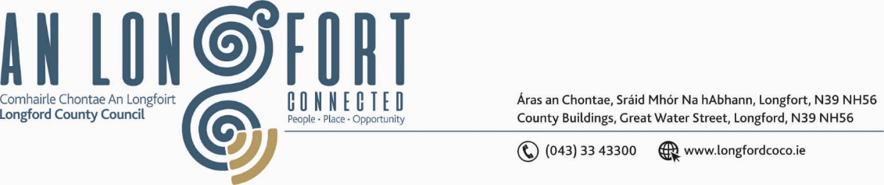

***BALLYMAHON MUNICIPAL DISTRICT***

***Please note meeting will be held in Ballymahon Library.***

**16th July 2021.**

**To: Each Member of Ballymahon Municipal District.**

**Dear Member,**

You are requested to attend a Meeting of Ballymahon Municipal District to be held

**in Ballymahon Library** on **Thursday, 22nd July 2021 at 4pm.** to transact business, as set out on the Agenda hereunder.

**Yours sincerely**,

Ann Marie Mc Keon

_______________

**Ann Marie Mc Keon,**

**Meetings Administrator.**

**AGENDA**

Prayer before meeting.

1. Confirmation of Minutes of Ballymahon Municipal District **-**

1. Meeting held on the 27th May 2021 – copy enclosed.
2. Committee Meeting held on the 27th May 2021 – copy enclosed.
3. Annual Meeting held on the 24th June 2021 – copy enclosed.

**2.** Matters arising from Minutes.

**3.** Declaration of Interest by Members.

**4.** Management Report - enclosed.

**5.** Risk Assessment – Attendance at Council Meetings by Elected Members & Council

Officials and attendance at other meetings or council buildings – enclosed.

**6.** Proposed Projects/Expression of interest – enclosed.

**7. Notices of Motions, submitted by Councillors, as listed hereunder –**

**Councillor Gerard Farrell**

(i) “I call on Longford County Council roads department to erect speed detection sign at Derryhawn housing estate”.

(ii) That Longford County Council supply signage and facilities to help with dog fouling issues at the community track in Lanesboro.

(iii) That Longford County Council erect a stop sign at the exit of Knock Manner

Lanesboro

**Councillor Paul Ross**

1. That Longford County Council install seats on the Ardagh Mountain walk

(ii) That a review of the footpaths in Ardagh Village be undertaken and new footpaths be prioritised for the village.

(iii) That a low-cost safety scheme be applied for on the Drumming /R393 junction at Ballycloughan in the interest of public safety.

**Councillor Pat O’Toole**

(i) I call on Longford County Council to engage with the relevant landowners between the new jetty at the Red Bridge Ballymahon and the Town Bridge in Ballymahon with a view to providing a walkway/cycleway between both bridges.

(ii) Could a copy of the consultant’s report on the proposed R392 realignment from the Abbeyshrule Road junction to Forgney Church be made available to the elected members of Ballymahon Municipal District with particular emphasis on what is proposed in relation to Route Option D i.e., the works proposed to improve the existing stretch of road.